МИНИСТЕРСТВО ОБРАЗОВАНИЯ И НАУКИ РОССИЙСКОЙ ФЕДЕРАЦИИ

ФЕДЕРАЛЬНОЕ государственное БЮДЖЕТНОЕ
образовательное учреждение
высшего образования
«НОВОСИБИРСКИЙ ГОСУДАРСТВЕННЫЙ ТЕХНИЧЕСКИЙ УНИВЕРСИТЕТ»
_______________________________________________________________________

Кафедра защиты информации



ОТЧЁТ
по лабораторной работе № 5
по дисциплине: « Языки программирования »

Выполнил: Проверил:
Студент гр. «АБС - 823», «АВТФ» «доцент Кафедры ЗИ»
«Кущенко М.С» «Крохалева А. Б »
«9» апреля 2019г. «9» апреля 2019 г.
_________________ _________________
(подпись) (подпись)

Новосибирск
2019
Задание 1. Вариант - 3
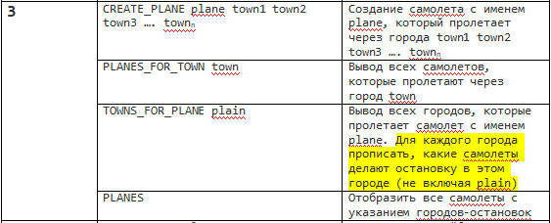
Листинг:
main.cpp
#include <iostream>
#include <string>
#include <map>
#include "logBook2.h"
enum COMANDS
{
CREATE_PLANE,
TOWNS_FOR_PLANE,
PLANES_FOR_TOWN,
PLANES
};

int main()
{
setlocale(0, "");
std::map<std::string, COMANDS> getEnum = { {static_cast<std::string>("CREATE_PLANE"), CREATE_PLANE}, {static_cast<std::string>("TOWNS_FOR_PLANE"), TOWNS_FOR_PLANE}, {static_cast<std::string>("PLANES_FOR_TOWN"), PLANES_FOR_TOWN}, {static_cast<std::string>("PLANES"),PLANES} };

int number;
addTowns_f({ "London", "Moscow", "Novosibirsk", "Pekin", "Tokyo", "Krasnoyarsk", "Frankfurt" });
std::cout << "Доступные города: London, Moscow, Novosibirsk, Pekin, Tokyo, Krasnoyarsk, Frankfurt" << std::endl;
std::cout << "Введите количество команд: ";
std::cin >> number;
COMANDS comand;

std::string comandString;
for (int i = 0; i < number; ++i)
{
std::cin >> comandString;
comand = getEnum[comandString];
std::vector<std::string> a;
std::string name;
std::string b="12";
switch (comand)
{
case COMANDS::CREATE_PLANE:
std::cin >> name;
while (std::cin.get() != '\n')
{
std::cin >> b;
a.push_back(b);
}
CREATE_PLANE_f(name, a);
break;
case COMANDS::PLANES:
PLANES_f();
break;
case COMANDS::PLANES_FOR_TOWN:
std::cin >> name;
PLANES_FOR_TOWN_f(name);
break;
case COMANDS::TOWNS_FOR_PLANE:
std::cin >> name;
TOWNS_FOR_PLANE_f(name);
break;
default:
std::cerr << "Error!" << std::endl;
}
}
system("pause");
return 0;
}
logBook.h
#pragma once
#include<vector>
#include<map>

class town;

class plane
{
private:
std::string name;
std::vector<town*> vectorOfTowns;
public:
std::string getName();
plane(std::string setName);
std::vector<town*> TOWNS();
void plane_add_towns(std::vector<std::string> Towns);
~plane();
};

class town
{
private:
std::string name;
std::vector<std::string> vectorOfPlanes;
public:
town(std::string setName);
void addToVector(std::string PlaneName);
std::vector<std::string> PLANES();
std::string getName();
};

void addTowns_f(std::vector<std::string> input);
void CREATE_PLANE_f(std::string name, std::vector<std::string> input);
void TOWNS_FOR_PLANE_f(std::string findThisName);
void PLANES_FOR_TOWN_f(std::string findThisName);
void PLANES_f();
logBook.cpp
#pragma once
#include "logBook2.h"
#include<iostream>
#include<vector>
#include<string>

std::vector<town> allTowns;
std::vector<plane> allPlanes;

plane::plane(std::string setName) : name(setName)
{
}

std::vector<town*> plane::TOWNS()
{
return vectorOfTowns;
}

void plane::plane_add_towns(std::vector<std::string> Towns)
{
int16_t i;
for (std::string townName : Towns)
{
i = 0;
for (town check : allTowns)
{
if (check.getName() == townName)
{
vectorOfTowns.push_back(&allTowns[i]);
allTowns[i].addToVector(this->name);
break;
}
++i;
}
}
}

std::string plane::getName()
{
return name;
}

plane::~plane()
{
}

town::town(std::string setName) :name(setName)
{
}
void town::addToVector(std::string PlaneName)
{
vectorOfPlanes.push_back(PlaneName);
}
std::string town::getName()
{
return name;
}
std::vector<std::string> town::PLANES()
{
return vectorOfPlanes;
}

void addTowns_f(std::vector<std::string> input)
{
for (std::string a : input)
{
town Town1(a);
allTowns.push_back(Town1);
}
}
void CREATE_PLANE_f(std::string name, std::vector<std::string> input)
{
plane a(name);
a.plane_add_towns(input);
allPlanes.push_back(a);
}
void TOWNS_FOR_PLANE_f(std::string findThisName)
{
for (plane checkName : allPlanes)
{
if (checkName.getName() == findThisName)
{
for (town* oneOfTowns : checkName.TOWNS())
{
std::cout << oneOfTowns->getName() << ' ';
}
}
}
std::cout << std::endl;
}
void PLANES_FOR_TOWN_f(std::string findThisName)
{
for (town checkName : allTowns)
{
if (checkName.getName() == findThisName)
{
for (std::string oneOfPlanes : checkName.PLANES())
{
std::cout << oneOfPlanes << ' ';
}
}
}
std::cout << std::endl;
}
void PLANES_f()
{
for (plane OneOfList : allPlanes)
{
std::cout << OneOfList.getName() << "\t";
for (town* oneOfTowns : OneOfList.TOWNS())
{
std::cout << oneOfTowns->getName() << ' ';
}
std::cout << std::endl;
}
}

Скриншоты:
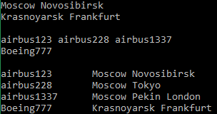
Задание 2. Вариант - 3
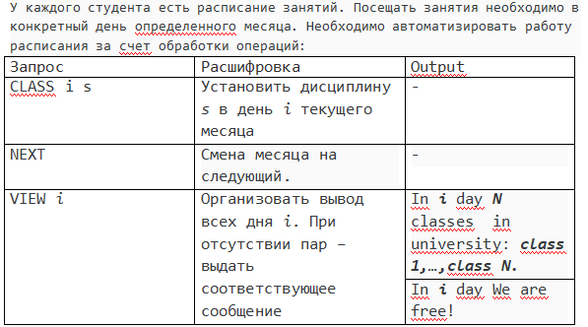
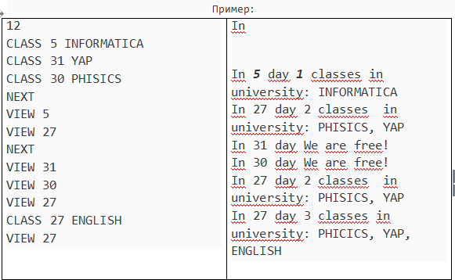
Листинг:
TimeTable.h
#pragma once
#include <vector>
#include <map>
void nextYear();
std::vector<int> nextMonth(std::map<int, std::vector<std::string>> &timetable);
void addLesson(std::map<int, std::vector<std::string>> &timetable, int day, std::string title);
void outPut(std::map<int, std::vector<std::string>> &timetable, int day);
void show_all(std::map<int, std::vector<std::string>> &timetable);
TimeTable.cpp
#pragma once
#include <iostream>
#include <string>
#include "TimeTable.h"

std::vector<int> month = { 31,28,31,30,31,30,31,31,30,31,30,31 };
int current_Month = 0;
int year = 2019;
void nextYear()
{
year++;
if (year % 4 == 0)
month[1] = 29;
else
month[1] = 28;
}
std::vector<int> nextMonth(std::map<int, std::vector<std::string>> &timetable)
{
std::vector<int> have_to_be_deleted;
current_Month = current_Month == 11 ? -1 : current_Month;
if (current_Month == 11)
{
current_Month = -1;
nextYear();
}

int current_count_of_days = month[++current_Month];

for (std::pair<int, std::vector<std::string>> a : timetable)
{
if (current_count_of_days < a.first)//Если в текущем месяце нет таких дней
{
for (std::string stroke : a.second)//Склеиваем два вектора
{
timetable[current_count_of_days - 1].push_back(stroke);
}
have_to_be_deleted.push_back(a.first);
}
}
return have_to_be_deleted;
}
void addLesson(std::map<int, std::vector<std::string>> &timetable, int day, std::string title)
{
if (day > 0 && day <= month[current_Month])
{
bool flag = 1;
for (std::string lesson : timetable[day])
{
if (lesson == title)
flag = 0;
}
if (flag)
{
timetable[day].push_back(title);
}
}
else
std::cerr << "Нет такого числа в этом месяце. Доступны числа от 1 до " << month[current_Month]<<std::endl;
}
void outPut(std::map<int, std::vector<std::string>> &timetable, int day)
{
if (timetable[day].size() != 0)
{
std::cout << "In " << day << " day " << timetable[day].size() << " classes in university : ";
for (std::string a : timetable[day])
std::cout << a << ' ';
std::cout << std::endl;
}
else
std::cout << "In " << day << " day We are free!" << std::endl;
}
void show_all(std::map<int, std::vector<std::string>> &timetable)
{
for (std::pair<int, std::vector<std::string>> a : timetable)
{
std::cout << "In " << a.first << " day " << timetable[a.first].size() << " classes in university : ";
for (std::string b : a.second)
std::cout << b;
std::cout << std::endl;
}
}
Main.cpp
#include <iostream>
#include <map>
#include <string>
#include <vector>
#include "TimeTable.h"
using namespace std;
enum timetable{CLASS, NEXT, VIEW, ALL};
int main()
{
setlocale(0, "");
cout << "Введите количество команд: ";
int number;
cin >> number;
map<string, timetable> getEnum = { {"CLASS", CLASS}, {"NEXT", NEXT}, {"VIEW", VIEW}, {"ALL", ALL} };
string comandString;
timetable comand;

std::map<int, std::vector<std::string>> timetable;

for (int i = 0; i < number; ++i)
{
std::cin >> comandString;
comand = getEnum[comandString];
int day;
string title;
std::vector<int> must_be_deleted;
switch (comand)
{
case timetable::CLASS:
cin >> day;
cin >> title;
addLesson(timetable, day, title);
break;
case timetable::NEXT:
must_be_deleted = nextMonth(timetable);
if (!must_be_deleted.empty())
{
for (int local : must_be_deleted)
{
timetable.erase(local);
}
}
break;
case timetable::VIEW:
cin >> day;
outPut(timetable, day);
break;
case timetable::ALL:
show_all(timetable);
break;
default:
std::cerr << "Error!" << std::endl;
}
}
system("pause");
return 0;
}
Скриншоты:
